**TOURS AND TRAVELS MANAGEMENT SYSTEM**

 **INTRODUCTION: -**

Nilesh Tours and travels is a travel company that provides various types of travel packages and services to the customers. Tours and travels management system is software system where the management of entire company is computerized. The tours and travels management system are designed using secured database. In this project the details are maintained like customers, seller, package, booking details. The company wants to track its customers bookings and generate reports to analyze its business performance.

**AIM OF PROJECT: -**

The aim of this project is to design and implement a Tours and Travels management system using SQL. The system stores and manages data about customers & sellers. The system will also provide various reports and queries to help the salesman and managers perform their tasks efficiently and effectively.

**OBJECTIVE OF PROJECT: -**

* To design a relational database for the tours and travels management system using SQL.
* To generate various reports and queries to support the decision making of the tours salesman and managers
* To document the system design, implementation, and testing process.

**This database contains four tables: -**

* Customers
* 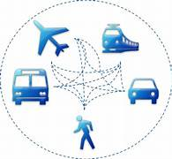Packages
* Booking
* Seller

|  |
| --- |
| CUSTOMER |
| PK cust_id int |
| Firstname varchar(25) |
| Lastname Varchar(30) |
| City Varchar(20) |
| Pincode int |
| Mob_NO Bigint |
| Email_id varchar(30) |
| DOB Date |

**ER DIAGRAM**

One to one

|  |
| --- |
| SELLER |
| PK Seller_id int |
| S_firstname varchar(30) |
| S_lastname varchar(30) |
| S_city varchar(20) |
| Mob_no bigint |
| Email_id varchar(30) |
| DOB date |
| Designation varchar(30) |
| Sal int |

|  |
| --- |
| BOOKING |
| PK Booking_id int |
| Fk tous_id int |
| Fk seller_id int |
| FK cust_id int |
| No_of_people int |
| Booking_date date |
| Payment_mode varchar(30) |
| Payment_status varchar(30) |

One to one

**Tours and Travels**

One to one

|  |
| --- |
| PACKAGE |
| PK Tour_id int |
| Tour_name varchar(200) |
| Duration int |
| Price int |
| Starting_date Date |
| Ending_date Date |
| Services varchar(250) |
| Max_capacity int |

**STRUCTURE OF TABLES: -**

1.Customer: -

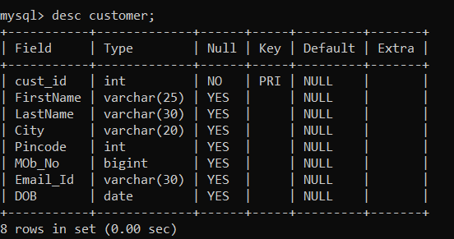

2.Seller: -

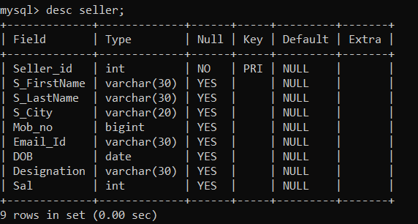

3.Pakage: -

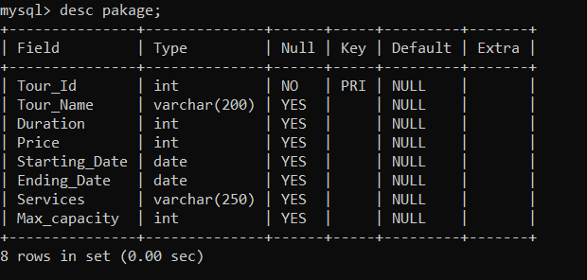

4.Booking: -

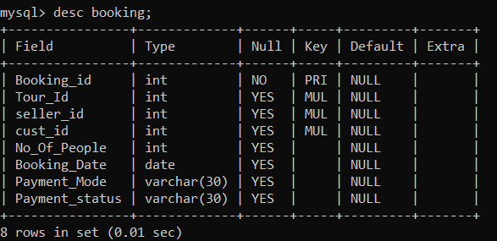

**CONTENT OF TABLES**

1.customer: -

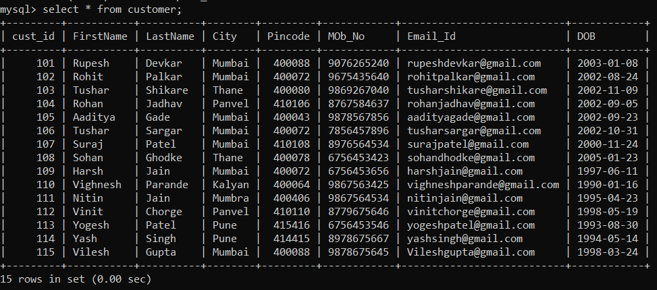

2.Seller: -

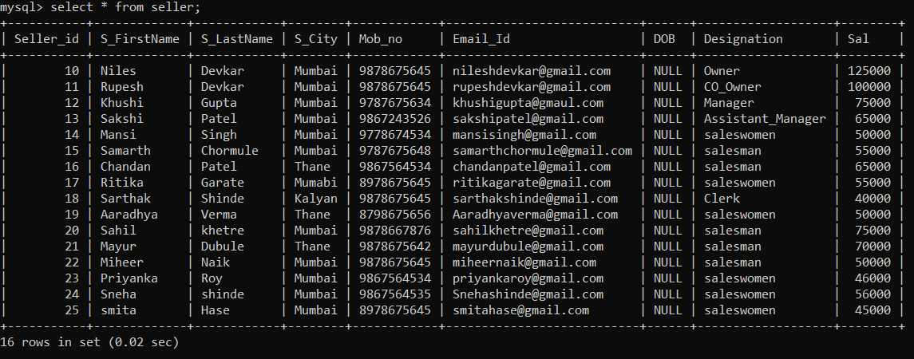

3. Package: -

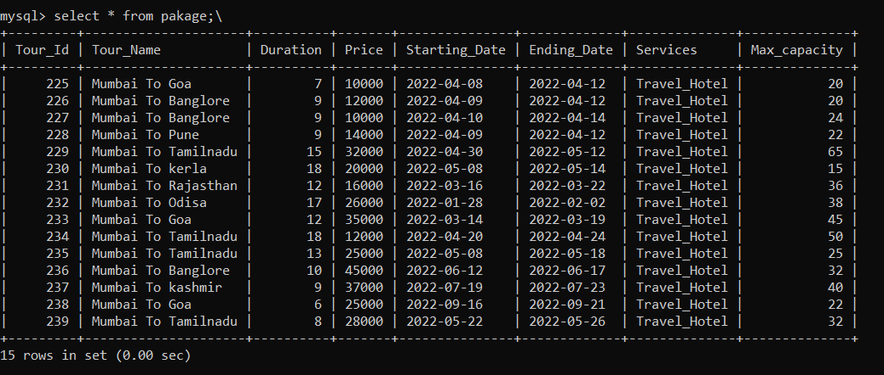

4. Booking: -

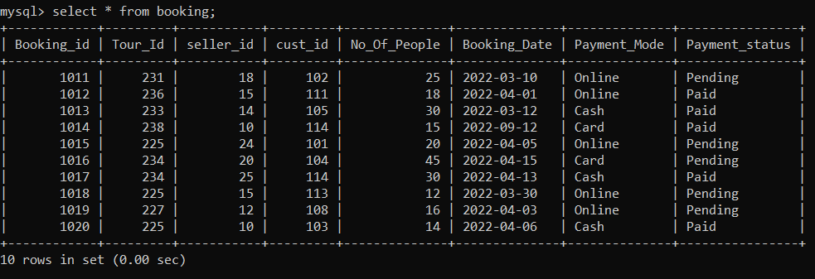

**A) Alter: -**

1. Add new column (service charge) after services

MySQL> alter table pakage

-> add column Service charge int after Services;

Query OK, 0 rows affected (0.08 sec)

Records: 0 Duplicates: 0 Warnings: 0

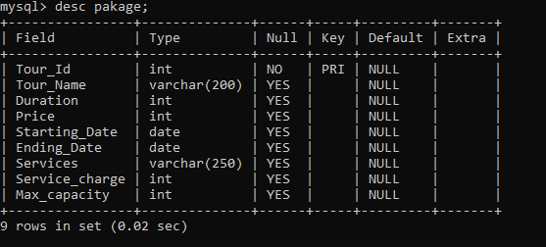

1. Rename column name Sal to salary

MySQL> alter table seller

-> rename column Sal to salary;

Query OK, 0 rows affected (0.03 sec)

Records: 0 Duplicates: 0 Warnings: 0

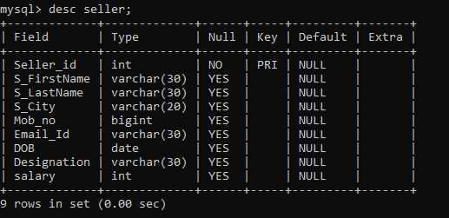

1. Rename table pakage to package

MySQL> alter table pakage

-> rename package;

Query OK, 0 rows affected (0.04 sec)

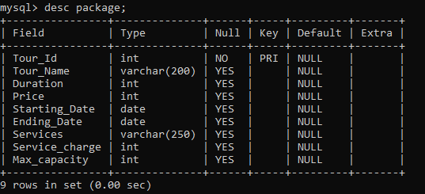

1. Drop column service charge

MySQL> alter table package

-> drop column service charge;

Query OK, 0 rows affected (0.03 sec)

Records: 0 Duplicates: 0 Warnings: 0

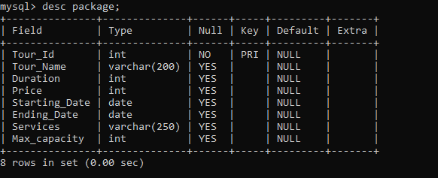

**B) Between: -**

5.Display the details of sellers who have salary between 75000 to 100000

MySQL> select * from seller where salary between 75000 and 100000;

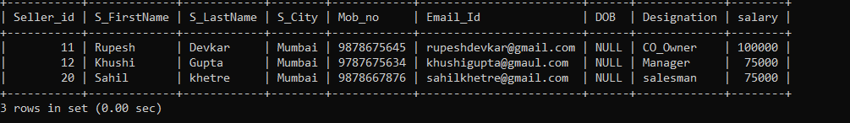

**C) In: -**

6. Display the details of package where it is 225,231,235.

MySQL> select * from package where tour _id in (225,231,235);

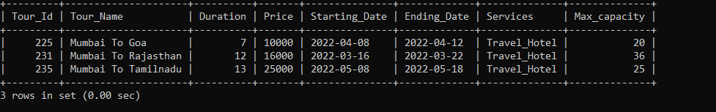

**D) comparison operators, Where Claus: -**

7. display the details of employee who have salary more than 75000.

MySQL> select * from seller where salary > 75000;

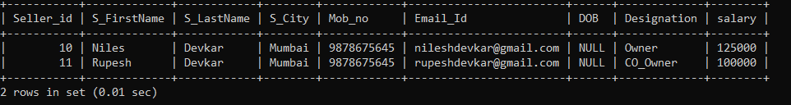

8. Display the details of packages where price is less than 15000.

MySQL> select tour_id, tour_name from package where price < 15000;

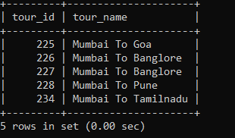

9. Display the details of bookings where 25 or more than 25 people have booked the tour.

select * from booking where No_Of_people >=25;

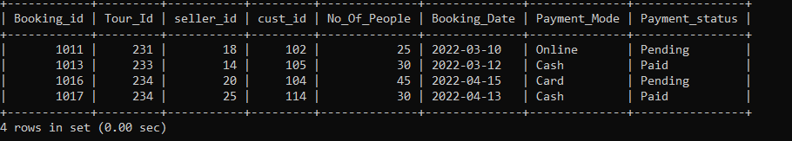

10.display the details of customer name Vighnesh.

select * from customer where first name= "Vighnesh";

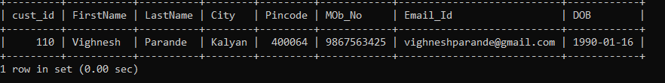

12. Display the details of seller who are not from Mumbai.

select seller_id, s_firstname, s_lastname from seller where s_city! ="Mumbai";

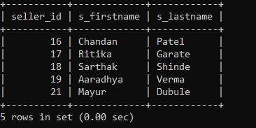

**E) Like: -**

13. display the details of sellers who have first letter s.

select * from seller where s_firstname like "s%";

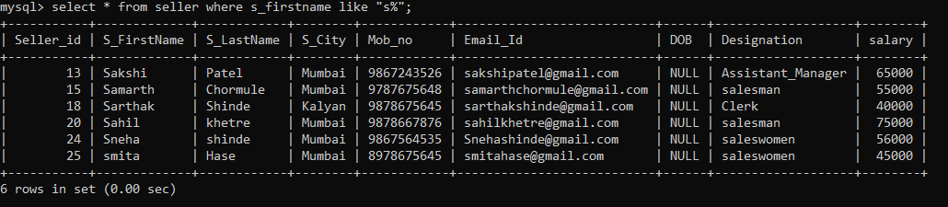

14. Display the details of seller where length of first letter is 5 and fourth letter of name is “a”.

MySQL> select * from customer where length (first name) =5 and first name like"%___a_%";

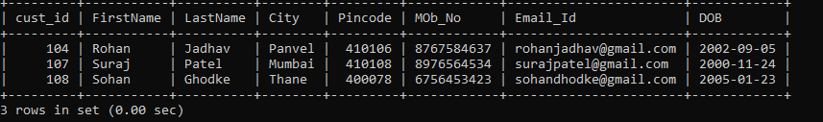

15.display the details of seller who have “a, c, d” in their name.

MySQL> select * from seller where S_firstname Rilke"[a/c/d]";

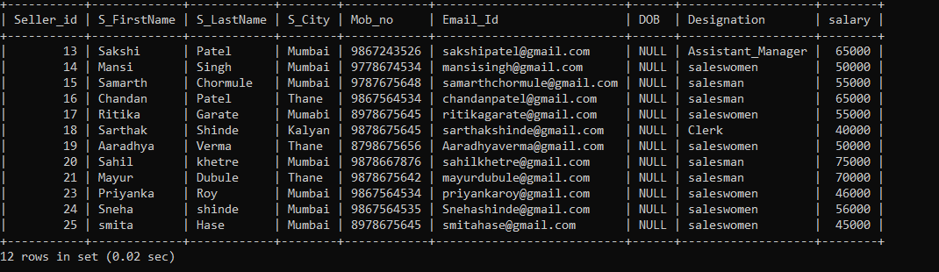

**F) Sub query: -**

16. Display 2rd highest salary.

MySQL> select * from seller where salary in (select max(salary) from seller where salary < (select max(salary) from seller));

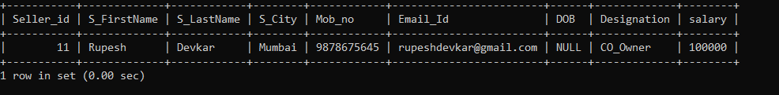

17. Display 3rd highest salary.

MySQL> select * from seller where salary in (select max(salary) from seller where salary< (select max(salary) from seller where salary < (select max (Salary) from seller)));

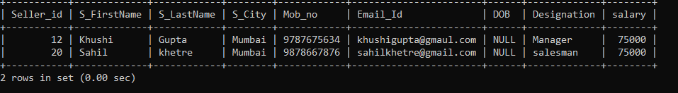

18. Display details of package where price of package is more than “Mumbai to Odissa” tour.

MySQL> select * from package where price> (select price from package where tour_name="Mumbai to Odissa");

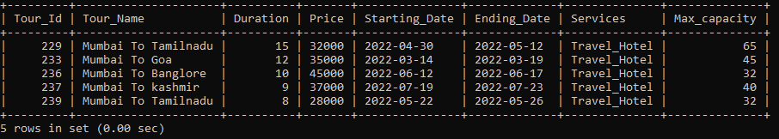

**G) Order, group, having: -**

19.Display the salary by ascending order.

MySQL> select * from seller order by salary;

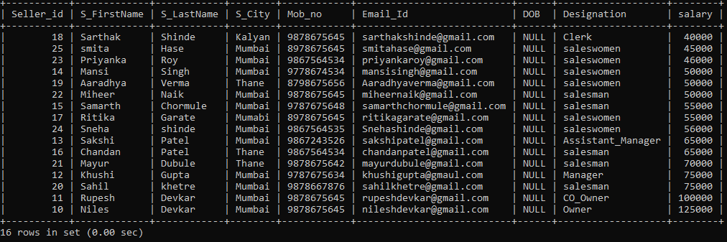

20. Display the details of min salary for each city.

select s_city, min(salary) from seller group by s_city;

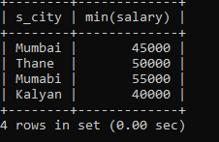

21. Display the total count of seller working in each city there should be at least 2 sellers.

MySQL> select s_city, count(seller_id) from seller group by s_city having count(s_city)>2;

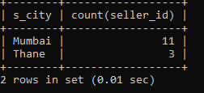

**H) Joins: -**

**22. Inner Join**

MySQL> select S_firstname, S_lastname, designation, booking_id, tour_id, booking date

-> from seller

-> inner join booking

-> on seller. seller_id=booking. Seller_id;

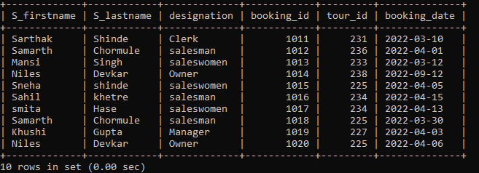

**23. Left Join**

MySQL> select * from package

-> left join booking

-> on package. Tour_id=booking. Tour_id;

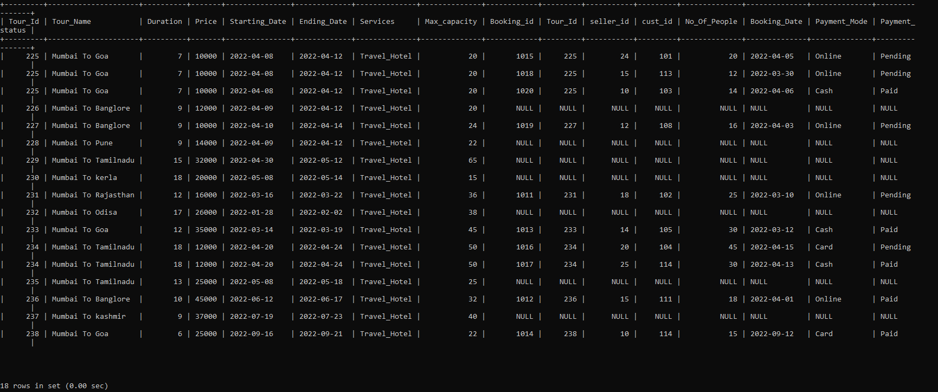

**24. Right Join**

MySQL> select * from customer

-> right join booking

-> on customer. cystoid=booking. cust_id;

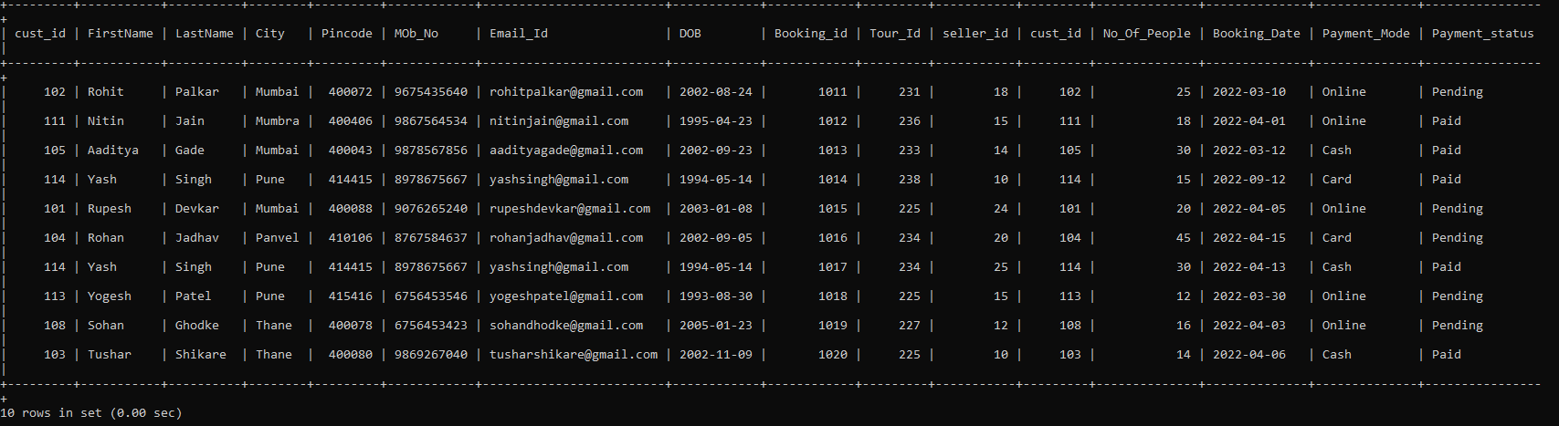

25. Alias

mysql> select salary as sal,s_firstname,S_lastname from seller;

